Procedure to Create a group in Amazon AWS
1.Open Amazon AWS and Sign in
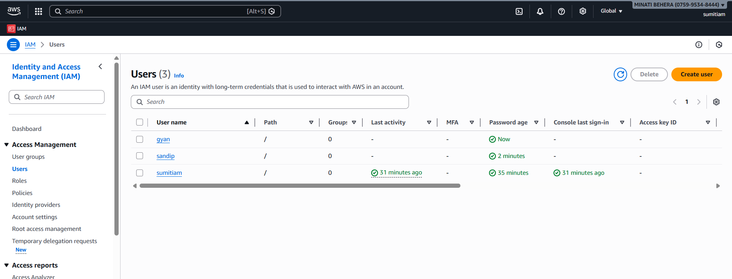
2.Go to usergroup icon
3.Go to Create croup
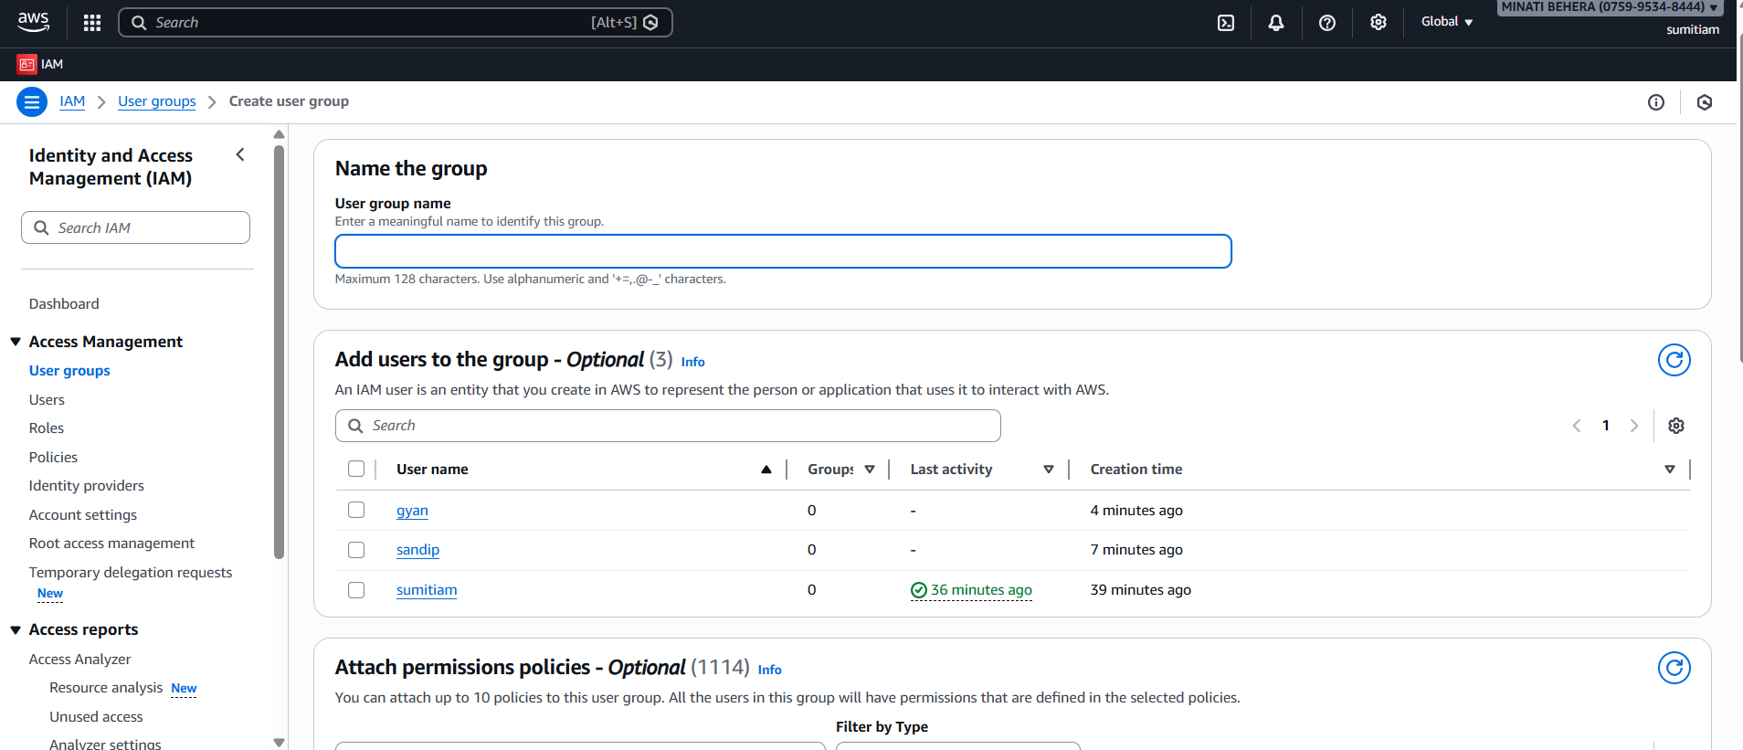
4.Enter Name of the group & Select User to the group & attach police
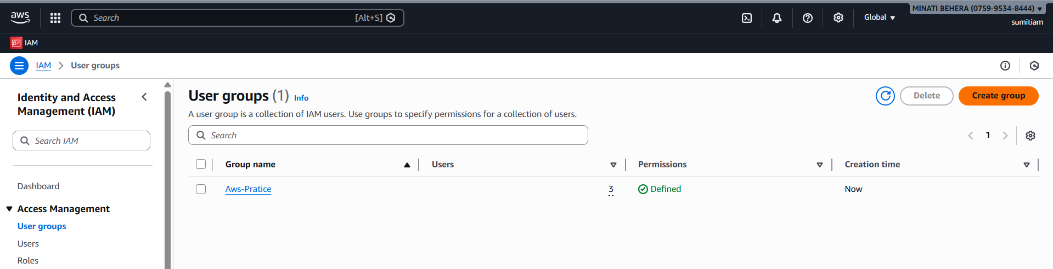
5.Group created Sucessfully
6.Go to darshaboard
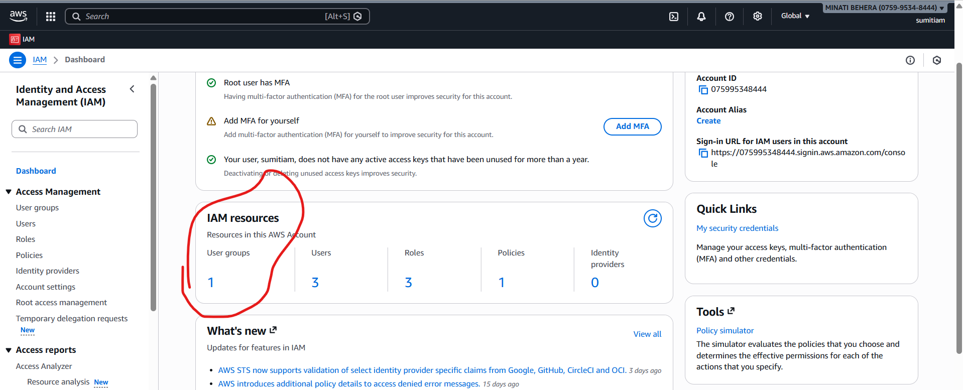
One group is Created

